**ASSIGNMENT 8.5**

**PIG SCRIPTS**

JSON to CSV

**LOADING**

grunt>a = LOAD '/user/acadgild/olympic.json' USING JsonLoader('athelete:chararray,age:INT,country:chararray,year:chararray,closing:chararray,sport:chararray,gold:INT,silver:INT,bronze:INT,total:INT');

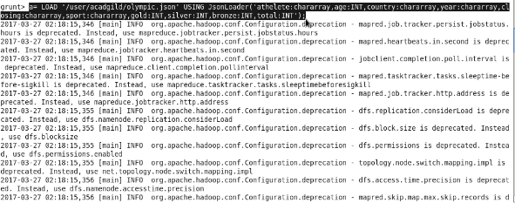

**STORING**

STORE a INTO '/jsontocsv' USING org.apache.pig.piggybank.storage.CSVExcelStorage();

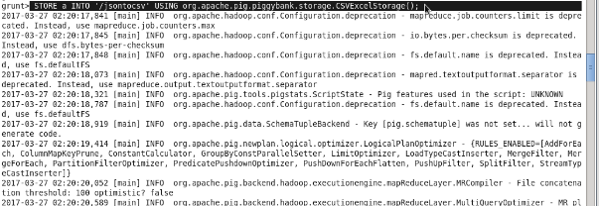

OUTPUT – BROWSER VIEW

